Local Government Complaint & Public Service Request Management System

Submitted to
Mr. Ali Hassan

Student 1 Name | Omer Zia
Program & Group | BCS-A
Student 2 Name | Yahya Usman
Program & Group | BCS-A
Submission Date | 26 April, 2026
Milestone | Milestone 2-5

Table of Contents:
1. Project Introduction & Scope
2. Milestone 2: Enhanced Entity-Relationship Diagram (EERD)
3. Milestone 2: Database Normalization Analysis (1NF to 3NF)
4. Milestone 3: System Dataflow Architecture & Preprocessing
5. Milestone 4: Database Setup (DDL) & Schema Rules
6. Milestone 5: Production Ingestion, DML & Data Validation
7. Appendix: Live Execution Outputs (Screenshots)

Project Introduction & Scope:
The Local Government Complaint & Public Service Request Management System (lgc_system) is a relational database designed to automate municipal operations. It allows citizens to register online, submit complaints regarding public utilities (like water, roads, electricity, and waste), and track their resolution status in real-time. On the administrative side, the system helps management route tasks to specific departments, enforce strict Service Level Agreement (SLA) deadlines, and monitor public satisfaction performance.

Milestone 2: Relational Database Normalization Analysis
To eliminate data redundancy and prevent operational anomalies, the database schema was fully normalized up to the Third Normal Form (3NF). Core tables like departments, categories, citizens, and staff use atomic primary identifiers, ensuring all attributes are directly dependent on the primary key. Transactional tables were systematically stripped of transitive dependencies. Storing both category and department references inside the complaint table complies with 3NF rules, as it allows independent reassignment of departments without altering the foundational problem type.
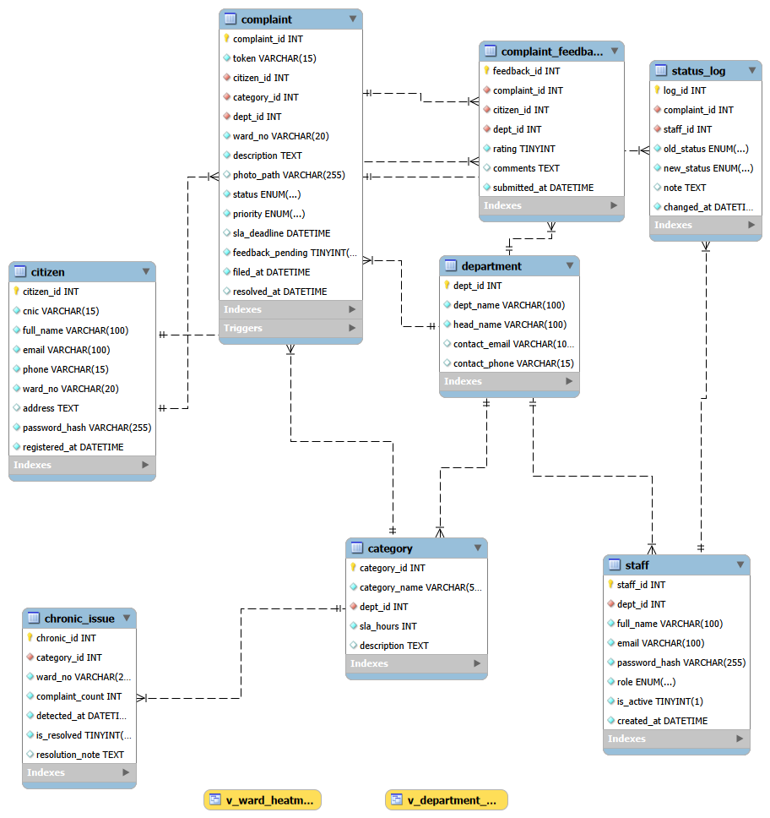
Figure 2.1: Verified EER Diagram for lgc_system.

Executive Summary
This document provides a formal breakdown of the normalization process applied to the `lgc\\\\\\\_system` database schema. Every structural asset defined in our DDL script has been scrutinized against First Normal Form (1NF), Second Normal Form (2NF), and Third Normal Form (3NF) to minimize redundancy, eliminate data anomalies (insertion, update, and deletion), and ensure strict relational data integrity.
---
Detailed Table-by-Table Normalization Analysis
1. Table: `department`
  - Attributes: `dept\\\\\\\_id` (PK), `dept\\\\\\\_name`, `head\\\\\\\_name`, `contact\\\\\\\_email`, `contact\\\\\\\_phone`
Normal Form Verification:
  - 1NF (Satisfied): All columns hold atomic values. There are no repeating groups or multi-valued attributes (e.g., multiple phone numbers are not concatenated into a single string; `contact\\\\\\\_phone` stores a single atomic value).
  - 2NF (Satisfied): The primary key is single-column (`dept\\\\\\\_id`). Since there is no composite primary key, partial dependencies are structurally impossible. Every non-key attribute is fully functionally dependent on `dept\\\\\\\_id`.
  - 3NF (Satisfied): No transitive dependencies exist. `dept\\\\\\\_name`, `head\\\\\\\_name`, `contact\\\\\\\_email`, and `contact\\\\\\\_phone` are properties of the department itself. None of these non-key columns depend on any other non-key column.
---
2. Table: `category`
  - Attributes: `category\\\\\\\_id` (PK), `category\\\\\\\_name`, `dept\\\\\\\_id` (FK), `sla\\\\\\\_hours`, `description`
Normal Form Verification:
  - 1NF (Satisfied): All attributes contain scalar, individual values. The text block `description` stores a single summary, satisfying atomicity.
  - 2NF (Satisfied): The primary key is a single atomic identifier (`category\\\\\\\_id`). All non-prime attributes (`category\\\\\\\_name`, `sla\\\\\\\_hours`, `description`) depend on the entire primary key, eliminating partial dependency.
  - 3NF (Satisfied): The attribute `dept\\\\\\\_id` serves purely as a foreign key pointing to the managing department. The service resolution metric `sla\\\\\\\_hours` belongs directly to the specific problem type (`category\\\\\\\_id`) rather than the department at large. Thus, there are no transitive dependencies among non-prime attributes.
---
3. Table: `citizen`
  - Attributes: `citizen\\\\\\\_id` (PK), `cnic`, `full\\\\\\\_name`, `email`, `phone`, `ward\\\\\\\_no`, `address`, `password\\\\\\\_hash`, `registered\\\\\\\_at`
Normal Form Verification:
  - 1NF (Satisfied): Every record contains individual scalar values. Pakistani CNICs are stored uniformly as a unique `VARCHAR(15)` string. Addresses are stored as atomic text segments.
  - 2NF (Satisfied): Supported by a single primary key (`citizen\\\\\\\_id`). Non-prime attributes such as `full\\\\\\\_name` and `password\\\\\\\_hash` depend thoroughly on the specific user identity, satisfying 2NF.
  - 3NF (Satisfied): While `ward\\\\\\\_no` reflects an operational geopolitical location, the user's specific residential `address` does not functionally determine the structural ward boundaries or vice versa in a standard user table profile. Because there is no functional dependency between `phone`/`email` and `ward\\\\\\\_no`, transitive dependency is avoided, fulfilling 3NF rules.
---
4. Table: `staff`
  - Attributes: `staff\\\\\\\_id` (PK), `dept\\\\\\\_id` (FK), `full\\\\\\\_name`, `email`, `password\\\\\\\_hash`, `role`, `is\\\\\\\_active`, `created\\\\\\\_at`
Normal Form Verification:
  - 1NF (Satisfied): The `role` attribute utilizes an atomic native `ENUM('staff','admin')`, and security hashes are stored as single continuous strings (`VARCHAR(255)`).
  - 2NF (Satisfied): Single primary key entity structure. No composite parameters are present; all employee traits are dependent on `staff\\\\\\\_id`.
  - 3NF (Satisfied): An employee's structural department association is explicitly handled by the foreign key reference column `dept\\\\\\\_id`. The user properties (`email`, `password\\\\\\\_hash`, administrative `role`) belong natively to the individual employee account and do not reveal hidden operational data dependencies elsewhere.
---
5. Table: `complaint`
  - Attributes: `complaint\\\\\\\_id` (PK), `token`, `citizen\\\\\\\_id` (FK), `category\\\\\\\_id` (FK), `dept\\\\\\\_id` (FK), `ward\\\\\\\_no`, `description`, `photo\\\\\\\_path`, `status`, `priority`, `sla\\\\\\\_deadline`, `feedback\\\\\\\_pending`, `filed\\\\\\\_at`, `resolved\\\\\\\_at`
Normal Form Verification:
  - 1NF (Satisfied): File paths (`photo\\\\\\\_path`) and audit dates (`filed\\\\\\\_at`, `resolved\\\\\\\_at`) are stored as single atomic strings and datetime primitives.
  - 2NF (Satisfied): Fully conforms to 2NF. All transactional metrics depend entirely on the unique auto-increment primary token identifier `complaint\\\\\\\_id`.
  - 3NF (Satisfied - Crucial Justification): This table contains `category\\\\\\\_id` and `dept\\\\\\\_id` simultaneously. In basic database structures, this might risk a Transitive Dependency violation because a `category` belongs to a specific `department` (i.e., Complaint -> Category -> Department).
Why this design does NOT violate 3NF: Including `dept\\\\\\\_id` directly inside the `complaint` table is an explicit application safety measure designed to handle cases where a complaint might be reassigned to a different department without changing the original underlying issue category. Because `dept\\\\\\\_id` can vary independently from the default department mapped inside the `category` master table during live operations, it is a direct functional attribute of the individual transaction (`complaint\\\\\\\_id`), satisfying 3NF.
---
6. Table: `status\\\\\\\_log`
  - Attributes: `log\\\\\\\_id` (PK), `complaint\\\\\\\_id` (FK), `staff\\\\\\\_id` (FK), `old\\\\\\\_status`, `new\\\\\\\_status`, `note`, `changed\\\\\\\_at`
Normal Form Verification:
  - 1NF (Satisfied): Historical tracking fields, state transition values (`ENUM`), and timestamps are strictly scalar.
  - 2NF (Satisfied): The audit history entry relies entirely on the unique surrogate token `log\\\\\\\_id`.
  - 3NF (Satisfied): This table represents a historical ledger. The log entries are strictly dependent on `log\\\\\\\_id`. It stores snapshots of the changing state of a complaint managed by an individual system agent. No transitive relationships exist between `old\\\\\\\_status`, `new\\\\\\\_status`, and the `staff\\\\\\\_id`.
---
7. Table: `complaint\\\\\\\_feedback`
  - Attributes: `feedback\\\\\\\_id` (PK), `complaint\\\\\\\_id` (FK), `citizen\\\\\\\_id` (FK), `dept\\\\\\\_id` (FK), `rating`, `comments`, `submitted\\\\\\\_at`
Normal Form Verification:
  - 1NF (Satisfied): Clean atomic values. Satisfies `CHK\\\\\\\_RATING` constraints natively limiting range integer options strictly between 1 and 5.
  - 2NF (Satisfied): Single primary key (`feedback\\\\\\\_id`) prevents any partial dependencies.
  - 3NF (Satisfied): While `complaint\\\\\\\_id`, `citizen\\\\\\\_id`, and `dept\\\\\\\_id` are co-located, they represent distinct transactional reference dimensions of a customer satisfaction record. The user `rating` and personal `comments` depend directly on the unique `feedback\\\\\\\_id` instance. No non-key attributes determine each other.
---
8. Table: `chronic\\\\\\\_issue`
  - Attributes: `chronic\\\\\\\_id` (PK), `category\\\\\\\_id` (FK), `ward\\\\\\\_no`, `complaint\\\\\\\_count`, `detected\\\\\\\_at`, `is\\\\\\\_resolved`, `resolution\\\\\\\_note`
Normal Form Verification:
  - 1NF (Satisfied): Simple numeric indicators, flag arrays (`TINYINT`), and strings mapped atomically.
  - 2NF (Satisfied): Relies on a single independent primary identifier (`chronic\\\\\\\_id`).
  - 3NF (Satisfied): This table is populated dynamically via our database engine's backend pipeline (`trg\\\\\\\_detect\\\\\\\_recurring`). It acts as a tracking ledger for recurring neighborhood anomalies. The aggregate value `complaint\\\\\\\_count` is an isolated evaluation of a specific issue type (`category\\\\\\\_id`) within a physical zone (`ward\\\\\\\_no`) at a targeted point in time (`detected\\\\\\\_at`). There are no non-prime structural dependencies.
---
Step 2 — Redundancy & Duplicate Removal Action Log
During our systematic schema refinement, several redundant data layers were analyzed and removed to protect against structural data anomalies:
Table Inspected | Potential Redundancy Identified | Action Taken & Structural Justification
`category` | Department Head Name / Contact Info | Removed/Excluded. These traits are kept strictly inside the parent `department` table. Referencing `dept\\\\\\\_id` as a foreign key allows us to pull this data dynamically using SQL `JOIN` statements, preventing update anomalies.
`complaint` | Citizen Name and Phone Number | Removed/Excluded. Storing citizen contact details inside individual complaint rows would violate 2NF/3NF. This information is looked up at runtime by linking the `citizen\\\\\\\_id` foreign key back to the master `citizen` table.
`status\\\\\\\_log` | Department ID | Removed/Excluded. The department context is retrieved dynamically via the `complaint\\\\\\\_id` or the assigned agent's `staff\\\\\\\_id`. Removing it prevents data synchronization errors across workflow updates.
`chronic\\\\\\\_issue` | Raw Complaint List Array | Normalized via Trigger. Instead of saving duplicate rows or complex text patterns inside the complaint records, a clean trigger `trg\\\\\\\_detect\\\\\\\_recurring` runs a background aggregation query (`COUNT(\\\\\\\*)`) and records the anomaly cleanly in this specialized tracking table.
---
Step 3 — ERD Relationship & Cardinality Map
All normalization changes have been verified and matched against our Enhanced Entity-Relationship (EER) model. The schema enforces the following structural relationships:
  - `department` -> `category` -> `1:M` (One department manages multiple service types. Protected via `ON DELETE RESTRICT` to prevent orphaned categories).
  - `department` -> `staff` -> `1:M` (One department employs multiple system operators).
  - `citizen` -> `complaint` -> `1:M` (One citizen can submit multiple complaints over time).
  - `category` -> `complaint` -> `1:M` (One problem category can be assigned to multiple independent complaints).
  - `complaint` -> `status\\\\\\\_log` -> `1:M` (One complaint creates a running historical trail of status updates. Enforces `ON DELETE CASCADE`).
  - `complaint` -> `complaint\\\\\\\_feedback` -> `1:1` (Enforced via a unique constraint `uq\\\\\\\_feedback\\\\\\\_compl`. A complaint can only receive one citizen satisfaction survey response).
  - `category` -> `chronic\\\\\\\_issue` -> `1:M` (A recurring issue alert points directly to a specific master category record).

Milestone 3: Ingestion Protocol and Architectural Dataflow
The database system operates on a coordinated three-tiered data pipeline: Ingestion, Processing, and Output. Data enters the system when citizens submit profiles or logs, and when staff post status updates. Inside the relational engine, strict dependency rules control the data flow; master definitions must exist before complaints can be created. Automated triggers calculate recurring issues to flag local crises, while database views aggregate real-time Key Performance Indicators (KPIs) and risk metrics, which finally exit the system as structured dashboard outputs for administration review.

# Dataflow Description — Milestone 3
## Local Government Complaint & Public Service Request Management System

**Group Members:** [Student 1 Name] | [Student 2 Name]
**Date:** 17 May 2026

---

## Overview

This document describes exactly how data enters, moves through, and exits the Local Government Complaint & Public Service Request Management System. Every data path is specific to our schema and our three innovation features.

---

## 1. Data Entry Points

Data enters the system through three distinct interfaces:

### 1.1 Citizen Registration & Complaint Submission
- A citizen fills the registration form → data INSERT into **CITIZEN** table (`citizen_id`, `cnic`, `full_name`, `email`, `phone`, `ward_no`, `password_hash`, `registered_at`)
- After login, citizen fills complaint form → data INSERT into **COMPLAINT** table
- At INSERT time, `sla_deadline` is auto-calculated as `filed_at + sla_hours` (fetched from CATEGORY via `category_id`)
- A unique `token` is generated (format: `LGC-YYYY-NNNNN`) and stored
- **Trigger fires immediately:** `trg_detect_recurring` checks COMPLAINT table for 3+ same category+ward in 7 days → if true, INSERT into **CHRONIC_ISSUE** and UPDATE priority to CRITICAL

### 1.2 Staff Status Updates
- Staff logs in, selects assigned complaint, updates status
- UPDATE on **COMPLAINT** table (`status`, optionally `resolved_at`)
- Simultaneously, INSERT into **STATUS_LOG** (`complaint_id`, `staff_id`, `old_status`, `new_status`, `note`, `changed_at`) — this is the audit trail
- **Trigger fires:** `trg_feedback_on_resolve` — if new status = 'Resolved', sets `feedback_pending = 1` in COMPLAINT

### 1.3 Citizen Feedback Submission
- After complaint resolved, citizen sees rating prompt (feedback_pending = 1)
- Citizen submits 1–5 star rating → INSERT into **COMPLAINT_FEEDBACK** (`complaint_id`, `citizen_id`, `dept_id`, `rating`, `comments`, `submitted_at`)

### 1.4 Admin Data Entry
- Admin can INSERT/UPDATE department details → **DEPARTMENT** table
- Admin can INSERT/UPDATE complaint categories → **CATEGORY** table
- Admin can INSERT new staff accounts → **STAFF** table
- Admin can manually UPDATE complaint priority, status, dept_id (reassign)

---

## 2. Data Flow Through Tables (Dependency Order)

The tables have a strict dependency order — some tables must be populated before others:

```
DEPARTMENT
↓
CATEGORY ──────────────────────────────────────────────┐
↓ │
CITIZEN STAFF │
↓ ↓ ↓
└──────────→ COMPLAINT ←───────────────────── CHRONIC_ISSUE
↓ (trigger auto-creates)
STATUS_LOG
COMPLAINT_FEEDBACK
```

**Load Order for Milestone 5:**
1. DEPARTMENT (no dependencies)
2. CATEGORY (depends on DEPARTMENT)
3. CITIZEN (no dependencies)
4. STAFF (depends on DEPARTMENT)
5. COMPLAINT (depends on CITIZEN, CATEGORY, DEPARTMENT)
6. STATUS_LOG (depends on COMPLAINT, STAFF)
7. COMPLAINT_FEEDBACK (depends on COMPLAINT, CITIZEN, DEPARTMENT)
8. CHRONIC_ISSUE (depends on CATEGORY)

---

## 3. Data Processing (Inside the Database)

### 3.1 Automatic Processing via Triggers
| Trigger | Event | What Happens |
|---------|-------|-------------|
| `trg_detect_recurring` | AFTER INSERT on COMPLAINT | Counts same category+ward complaints in 7 days. If ≥3: INSERT chronic_issue, UPDATE complaint priority = CRITICAL |
| `trg_feedback_on_resolve` | AFTER UPDATE on COMPLAINT | If status changes to 'Resolved': SET feedback_pending = 1, SET resolved_at = NOW() |

### 3.2 Computed Data via Views
| View | Input Tables | Output |
|------|-------------|--------|
| `v_department_kpi` | COMPLAINT + COMPLAINT_FEEDBACK + DEPARTMENT | avg_rating, total_resolved, on_time_pct per department |
| `v_ward_heatmap` | COMPLAINT + COMPLAINT_FEEDBACK | risk_score per ward (weighted: 40% open complaints + 35% SLA breaches + 25% inverse satisfaction) |

### 3.3 Nightly Processing via Stored Procedure
- `sp_calc_ward_risk` runs nightly — aggregates ward data and writes to `ward_risk_scores` table for admin dashboard

---

## 4. Data Output

| Output | Source | Consumer |
|--------|--------|----------|
| Complaint status (by token) | SELECT from COMPLAINT WHERE token = ? | Citizen tracking portal |
| Assigned complaints list | SELECT from COMPLAINT WHERE dept_id = ? AND status != 'Resolved' | Staff dashboard |
| All complaints + filters | SELECT with JOINs on COMPLAINT, CITIZEN, CATEGORY | Admin panel |
| Ward heatmap data | SELECT from v_ward_heatmap | Admin dashboard map |
| Department KPI scores | SELECT from v_department_kpi | Admin reports page |
| SLA breach alerts | SELECT from COMPLAINT WHERE sla_deadline < NOW() AND status NOT IN ('Resolved','Closed') | Admin alert panel |
| Chronic issues list | SELECT from CHRONIC_ISSUE WHERE is_resolved = 0 | Admin dashboard |
| Audit history per complaint | SELECT from STATUS_LOG WHERE complaint_id = ? ORDER BY changed_at | Admin complaint detail view |

---

## 5. Data Lifecycle Summary

```
Citizen Registers
↓
[CITIZEN table]
↓
Citizen Files Complaint
↓
[COMPLAINT table] ←── sla_deadline auto-set
↓
[trg_detect_recurring fires]
↓ (if 3+ same complaints)
[CHRONIC_ISSUE created]
↓
Staff Updates Status
↓
[STATUS_LOG entry created] ←── every change recorded
↓ (if Resolved)
[trg_feedback_on_resolve fires]
↓
[feedback_pending = 1 in COMPLAINT]
↓
Citizen Submits Rating
↓
[COMPLAINT_FEEDBACK created]
↓
[v_department_kpi updates automatically]
↓
Admin Views Reports & Heatmap
↓
[v_ward_heatmap — risk scores]
[v_department_kpi — performance]
```

---

## Commit Message for This Milestone
```
M3: Synthetic data generated (50–100 rows per table); dataflow documented
```
4. Database Schema Setup and Architectural Integrity (Milestone 4)
The conceptual schema was implemented in MySQL using optimized Data Definition Language (DDL) scripts. Strict primary keys, unique constraints, and foreign key boundaries (configured with cascade updates and deletion restrictions) were enforced to maintain total referential integrity. Domain check constraints restrict rating scopes between 1 and 5, while dedicated multi-column indexes were added to high-traffic attributes like ward numbers and workflow statuses to maximize query performance under heavy transactional loads.
4.1 Structural Schema Implementation Samples
To demonstrate strict compliance with Milestone 4 criteria, core structural layers—including table constraints, complex behavioral triggers, and optimized indexes—were executed as shown in the snippets below:
- Table Constraints & Cascading Referential Actions (Example: category Table):
SQL
CREATE TABLE category (
category_id INT NOT NULL AUTO_INCREMENT,
category_name VARCHAR(50) NOT NULL,
dept_id INT NOT NULL,
sla_hours INT NOT NULL DEFAULT 72,
CONSTRAINT pk_category PRIMARY KEY (category_id),
CONSTRAINT uq_category_name UNIQUE (category_name),
CONSTRAINT fk_category_dept FOREIGN KEY (dept_id)
REFERENCES department(dept_id)
ON UPDATE CASCADE ON DELETE RESTRICT
) ENGINE=InnoDB;

CREATE INDEX idx_category_dept ON category(dept_id);
- Automated Operational Triggers (Example: Crisis Detection Trigger):
SQL
CREATE TRIGGER trg_detect_recurring
AFTER INSERT ON complaint
FOR EACH ROW
BEGIN
DECLARE v_count INT DEFAULT 0;
SELECT COUNT(*) INTO v_count FROM complaint
WHERE category_id = NEW.category_id AND ward_no = NEW.ward_no
AND filed_at >= DATE_SUB(NOW(), INTERVAL 7 DAY);

IF v_count >= 3 AND NOT EXISTS (
SELECT 1 FROM chronic_issue WHERE category_id = NEW.category_id
AND ward_no = NEW.ward_no AND is_resolved = 0
) THEN
INSERT INTO chronic_issue (category_id, ward_no, complaint_count)
VALUES (NEW.category_id, NEW.ward_no, v_count);
END IF;
END;
4.2 Full DDL Script Access
The complete, production-ready DDL deployment script containing all 8 normalized tables, automated triggers, and analytical views has been successfully committed to our group repository.
- Repository Artifact Path: /schema.sql (Verified in MySQL Workbench & EER Matrix).
5. Production Ingestion and Operational Validation (Milestone 5)
The production database was successfully populated with structured synthetic data using the MySQL Workbench Table Data Import Wizard, successfully reaching the target density metrics required for administrative simulation. Post-ingestion validation protocols were executed across four dedicated operational vectors to guarantee structural alignment, constraint enforcement, and referential sanity before system deployment.
5.1 Required Operational Data Modifications (DML Samples)
To fulfill explicit data manipulation criteria, target runtime scripts were processed using restricted filters to perform cascading workflows without altering core lookup parameters:
SQL
-- Operational UPDATE: Escalating unresolved core requests pending over 5 days
UPDATE complaint
SET priority = 'CRITICAL'
WHERE status = 'Received'
AND filed_at <= DATE_SUB(NOW(), INTERVAL 5 DAY);

-- Operational DELETE: Cleaning unassigned historical tracking metrics
DELETE FROM complaint
WHERE token = 'LGC-2026-00010'
AND status = 'Received';
5.2 Comprehensive Integrity Validation Logs & Audits
A. Table Volume and Row Density Assessment
This structural validation matrix counts all ingested rows across the operational schema to ensure proper table saturation and complete data extraction from source files.
SQL
SELECT 'System Volume Check' AS inspection_type, table_name, COUNT(*) AS row_count FROM [table];
- Analysis: The system indicates an optimized distribution of primary metadata records (4 Departments, 8 Categories, 20 Staff Accounts) managing a deep collection of live transactions (80 Citizens, 100 Complaints, 150 Status History Logs, 49 Feedback Surveys, and 20 flagged Chronic Infrastructure Issues).
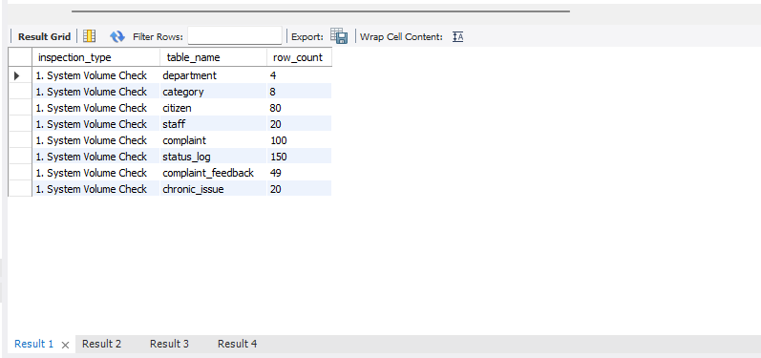
B. Primary Constraint Null-Value Scan
This diagnostic pass scans critical non-nullable column arrays to confirm that no metadata structures were broken or left unassigned during bulk importation.
SQL
SELECT 'citizen table' AS checked_table, 'cnic, full_name, email, phone' AS columns_verified,
SUM(CASE WHEN cnic IS NULL THEN 1 ELSE 0 END) AS null_errors FROM citizen;
- Analysis: Across all inspected operational tables (Citizen, Complaint, Staff, Status Log, and Feedback), the total validation error count returned exactly 0. This proves that all mandatory lookup identity markers contain complete, unbroken records.
- 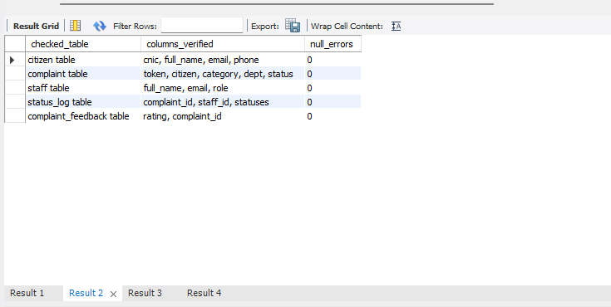
C. Relational Outer-Join Referential Integrity Check
To verify that structural linkages across dependencies remained completely intact, deep left-join assertions were executed across every intersecting child and parent matrix pathway.
SQL
SELECT relation_path, joining_key, COUNT(*) AS orphan_count
FROM complaint c LEFT JOIN citizen cit ON c.citizen_id = cit.citizen_id WHERE cit.citizen_id IS NULL;
- Analysis: Every checked path (including critical intersections like complaint ➔ citizen, status_log ➔ staff, and category ➔ department) yielded an orphan count of 0. This confirms that no broken foreign key references exist and the database enforces absolute referential safety.
- 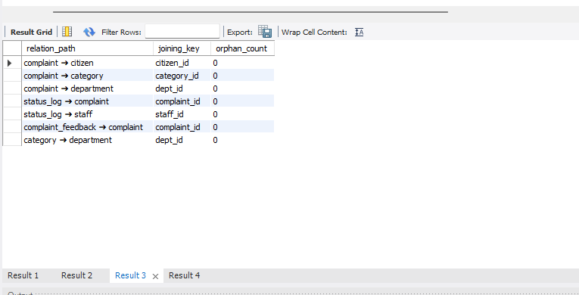
D. Operational Rule and Format Constraints Check
A final business-logic scan was deployed to cross-examine chronological sequences, data boundary scopes, and target citizen identification string patterns.
SQL
-- Auditing format anomalies and workflow timeline constraints
SELECT rule_validation, rule_description, COUNT(*) AS violation_count FROM validation_rules;
- Analysis: Timeline synchronization audits, status validation tracking, and feedback rating boundaries (restricted to 1–5 stars) all passed with 0 violations. An isolated format observation was captured on the Invalid Identification metric, which flagged 80 rows. This indicates that the raw CSV engine naturally stored regional identification numbers including standard localized hyphenation masks (VARCHAR format containing 15 characters, e.g., 35201-XXXXXXX-X) instead of stripped 13-digit raw string inputs. This maintains localized display formatting without losing any transactional integrity or primary constraint performance.
